**Build a Web App with ASP.NET Core and MongoDB**

[[Sena Kılıçarslan](https://medium.com/@sena.kilicarslan?source=post_page-----f9fcd61cb04f--------------------------------)](https://medium.com/@sena.kilicarslan?source=post_page-----f9fcd61cb04f--------------------------------)

[[.NET Core](https://medium.com/net-core?source=post_page-----f9fcd61cb04f--------------------------------)](https://medium.com/net-core?source=post_page-----f9fcd61cb04f--------------------------------)

[Sena Kılıçarslan](https://medium.com/@sena.kilicarslan?source=post_page-----f9fcd61cb04f--------------------------------)

·

[Follow](https://medium.com/m/signin?actionUrl=https%3A%2F%2Fmedium.com%2F_%2Fsubscribe%2Fuser%2F857bd90713e&operation=register&redirect=https%3A%2F%2Fmedium.com%2Fnet-core%2Fbuild-a-web-app-with-asp-net-core-and-mongodb-f9fcd61cb04f&user=Sena+K%C4%B1l%C4%B1%C3%A7arslan&userId=857bd90713e&source=post_page-857bd90713e----f9fcd61cb04f---------------------post_header-----------)

Published in

[.NET Core](https://medium.com/net-core?source=post_page-----f9fcd61cb04f--------------------------------)

·

9 min read

·

May 29, 2019

486

6

In this post, I will show how to build a web application using ASP.NET Core MVC and MongoDB. If you are not familiar with MongoDB, you may want to read my [Introduction to MongoDB](https://medium.com/@sena.kilicarslan/introduction-to-mongodb-2f81773c3c4f) post first.

Our application will manage a database of cars in a car gallery and its main page will look like below at the end.

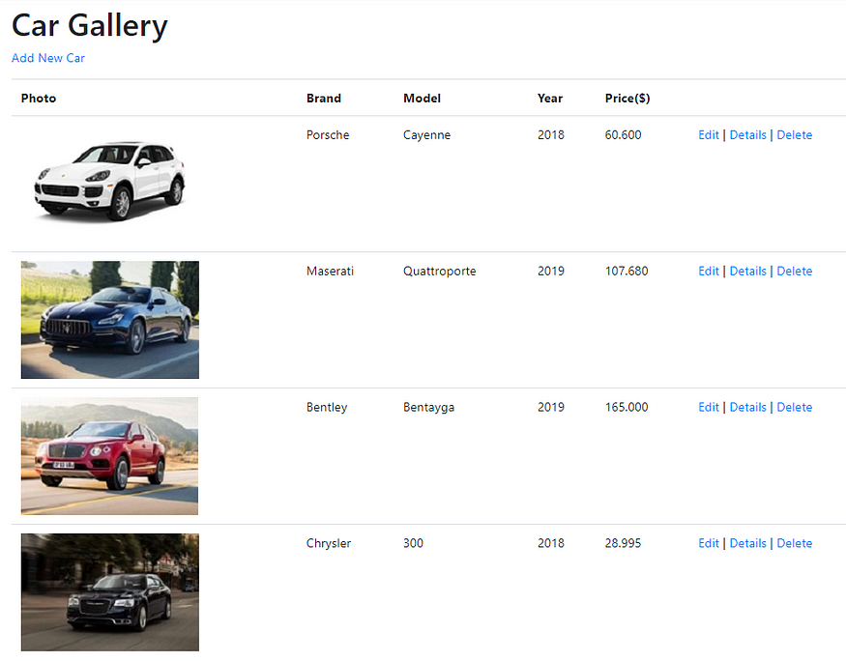

I will use the following tools for application development:

* [Visual Studio 2019 Community Edition (free)](https://visualstudio.microsoft.com/downloads/)
* [.Net Core SDK 2.2 (free)](https://dotnet.microsoft.com/download/dotnet-core)
* [MongoDB (free)](https://www.mongodb.com/download-center/community)

The sections of this post will be as follows:

* MongoDB Installation and Configuration
* Creating the ASP.NET Core MVC Project
* Adding a Model
* Adding a CRUD Services Class
* Adding a Controller
* Index Method and View
* Create Method and View
* Edit Method and View
* Details Method and View
* Delete Method and View

**MongoDB Installation and Configuration**

*I explained these instructions in detail in the****Installation and Configuration****section of the*[*post*](https://medium.com/@sena.kilicarslan/introduction-to-mongodb-2f81773c3c4f)*that I mentioned above.*

I am using Windows 10 so I will give the instructions for Windows.

1. Go to [this site](https://www.mongodb.com/download-center/community) and download MongoDB for your OS version.

MongoDB is installed at *C:\Program Files\MongoDB* by default. In the *C:\Program Files\MongoDB\Server\{version\_number}\bin folder* there are two executables: **mongod**and **mongo.**

2. Go to*Control Panel -> System -> Advanced System Settings -> Environment Variables* and edit ***Path***variable and add *C:\Program Files\MongoDB\Server\{version\_number}\bin* to that. ***This change enables MongoDB access from anywhere on your machine.***

3. MongoDB’s default directory for data storage is /data/db. Create these directories in your C drive.

4. Open a command prompt and run the following command.

mongod

5. Open a ***new command prompt*** and run the below command:

mongo

We will run all our mongo shell methods in this command shell.

6. Run the following command:

use CarGalleryDb

This command creates the database if it does not exist. If it exists, its connection is opened for transactions.

7. Create a *Cars* collection using the following command:

db.createCollection('Cars')

Now, our database and collection are ready. We will perform CRUD operations on the *Cars* collection in the next sections.

**Creating the ASP.NET Core MVC Project**

Open ***File -> New -> Project***..

Select ***ASP.NET Core Web Application*** and click Next.

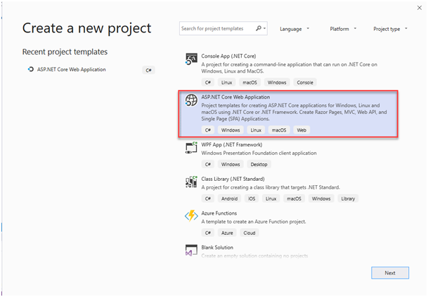

In the next window, name the project and solution and click Create.

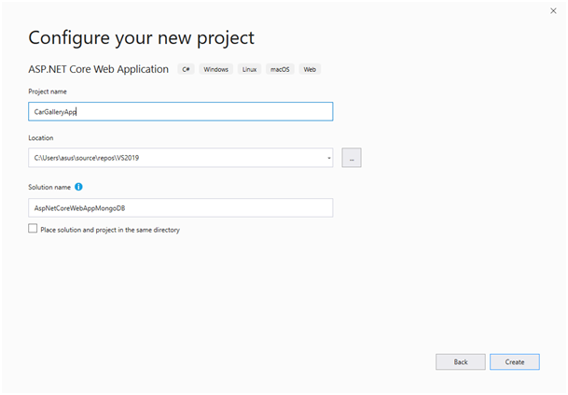

In the next window, select ***.Net Core*** and ***ASP.Net Core 2.2*** as shown in the red box and select ***Web Application (Model-View-Controller)***as project templateand then click Create.

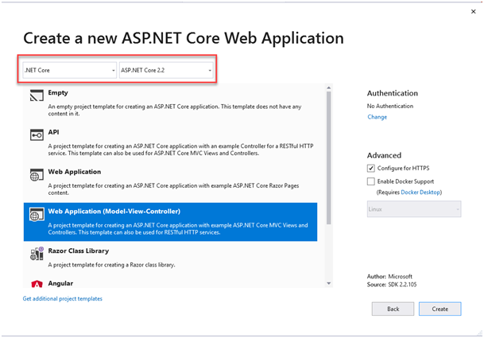

Now, we will add the MongoDB driver to our project.

Right-click on the project and select ***Manage Nuget Packages…***

In the Browse tab, search for *mongodb*and install the ***MongoDB.Driver***:

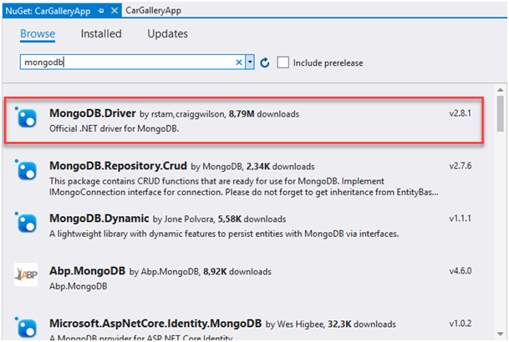

In the ***Views/Shared/\_Layout.cshtml*** file, make the following changes in the title, menu link and the footer.

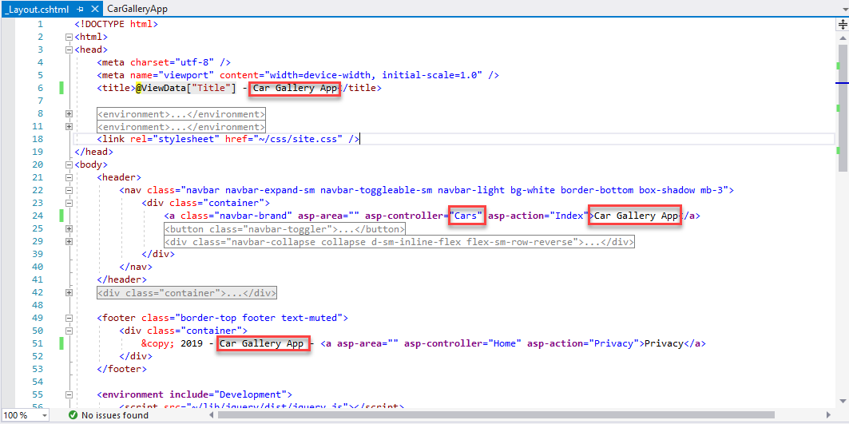

Now, let’s run our project (Ctrl + F5) and see if everything is OK.

You can change the browser that you want to run the site from below:

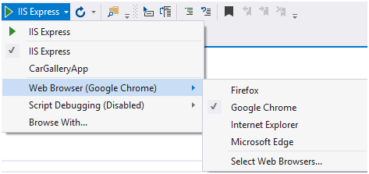

After running, we get the Welcome page as below:

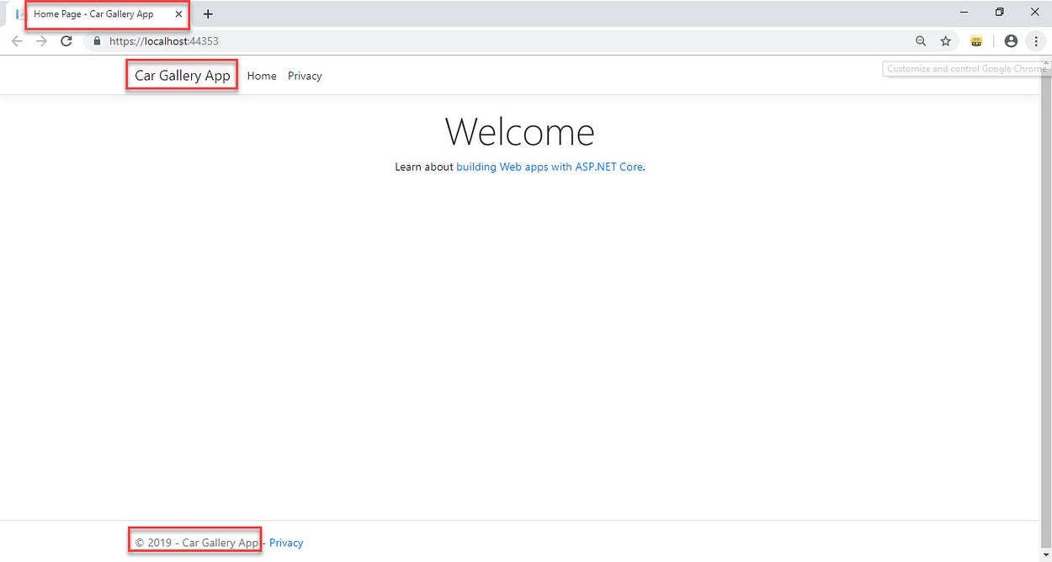

**Adding a Model**

Now, we will implement our data model class (***M****odel* part of the **M**VC app).

Right-click the ***Models***folder and select ***Add->Class****.*

Give the name ***Car.cs*** to the class and click Add.

Then add the following properties to the class:

In the preceding class, the Id property:

* is required for mapping the Common Language Runtime (CLR) object to the MongoDB collection.
* is annotated with [BsonId] to designate this property as the document’s primary key.
* is annotated with [BsonRepresentation(BsonType.ObjectId)] to allow passing the parameter as type string instead of ObjectId . Mongo handles the conversion from string to ObjectId.

Other properties in the class are annotated with the [BsonElement] attribute. The attribute’s value represents the property name in the MongoDB collection.

[YearRange] attribute is a custom attribute that allows only a valid range for the *Year*property. If you want to use this attribute, add ***CustomAttributes*** folder in the project as a new folder and add the following class there:

*You can change the range as you want.*

**Adding a CRUD Services Class**

In this section, we will addthe ***CarService***class which uses the MongoDB.Driver members to perform CRUD operations against the database.

First, add a ***Services***directory to the project root.

Then, add a *CarService*class to this directory with the following code:

Next**,**add the MongoDB connection string to ***appsettings.json***:

"ConnectionStrings": {  
 "CarGalleryDb": "mongodb://localhost:27017"  
 }

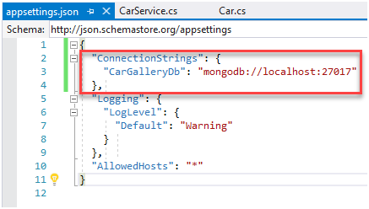

appsettings.json

The CarGalleryDb property is accessed in the *CarService*class constructor.

Now, let’s examine the ***CarService***class:

The *CarService*class uses the following MongoDB.Driver members to perform CRUD operations against the database:

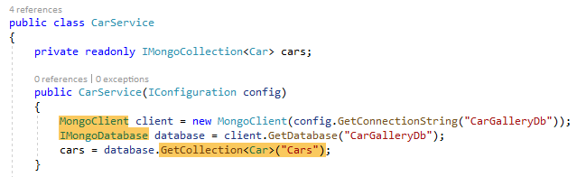

CarService.cs

MongoClient : Reads the server instance for performing database operations. The constructor of this class is provided the MongoDB connection string.

IMongoDatabase : Represents the Mongo database for performing operations. Generic GetCollection<T>(collection) method on the interface is used to gain access to data in a specific collection. CRUD operations can be performed against the collection after this method is called. In the GetCollection<T>(collection) method call:

* collection represents the collection name in the database.
* T represents the CLR object type stored in the collection.

GetCollection<T>(collection) returns a MongoCollection object representing the collection. The following methods are invoked on the collection:

* Find<T> : Returns all documents in the collection matching the provided search criteria.
* InsertOne : Inserts the provided object as a new document in the collection.
* ReplaceOne: Replaces the single document matching the provided search criteria with the provided object.
* DeleteOne: Deletes a single document matching the provided search criteria.

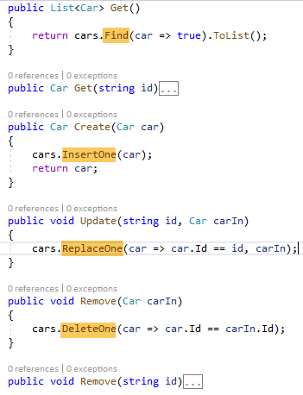

**Registering the CarService with the Dependency Injection System**

ASP.NET Core is built with [***Dependency Injection (DI)***](https://docs.microsoft.com/en-us/aspnet/core/fundamentals/dependency-injection?view=aspnetcore-2.2). Services are registered with DI during application startup. Components that require these services are provided with these services via constructor parameters.

Now, we will register the *CarService*class with the Dependency Injection system.

Add the following code shown in the red box to the ConfigureServices method of ***Startup.cs****:*

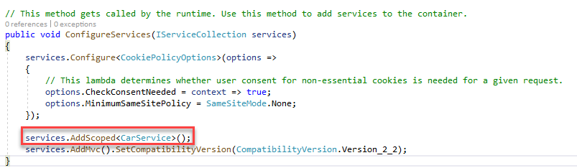

Startup.cs

Now, let’s build the solution to check if everything is OK.

**Adding a Controller**

In this section, we will implement our controller (***C****ontroller* part of the MV**C** app).

Right-click on the ***Controllers***folder and select ***Add Controller…***

In the Add Scaffold dialog, select ***MVC Controller with read/write actions*:**

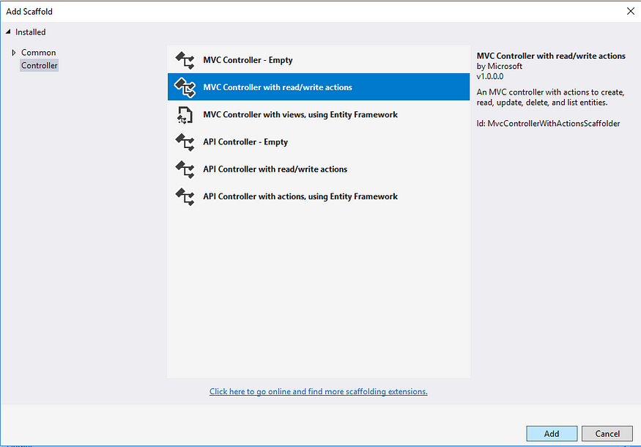

Give ***CarsController***as the name and then click Add.

Add the following highlighted code to the ***CarsController.cs***:

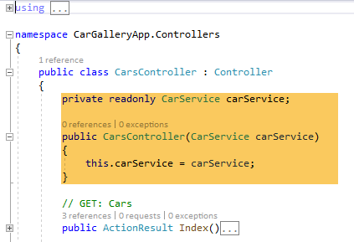

In the next sections, we will implement controller methods and the views associated with them.

**Index Method and View**

Change the Index method in*CarsController.cs* as follows:

Then, right-click on the ***Index***method and select ***Add View…***

Select the template and model class as shown below and click Add.

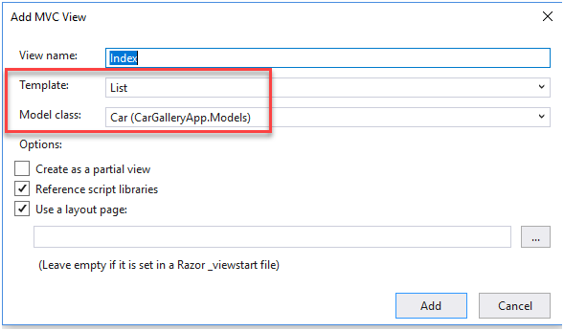

***Cars***folder and ***Index.cshtml*** are created in the ***Views***folder after this operation:

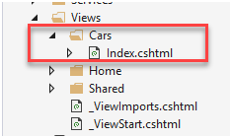

Open the ***Index.cshml*** and make the following changes:

* Remove the *Id* fields
* Change the title *Index*to ***Car Gallery***
* Change *Create New* to ***Add New Car***
* Move the *ImageUrl*field to the up and change it to:

@if (item.ImageUrl != null){ <img src="@Url.Content(item.ImageUrl)" alt="Image" />}

* Update the action links at the bottom as below:

<td> @Html.ActionLink(“Edit”, “Edit”, new { **id=item.Id** }) | @Html.ActionLink(“Details”, “Details”, new { **id=item.Id** }) | @Html.ActionLink(“Delete”, “Delete”, new { **id=item.Id** })</td>

*Index.cshtml* should be as follows at the end:

Run the application and click ***Car Gallery App*** in the *Home*page. You should get the following result:

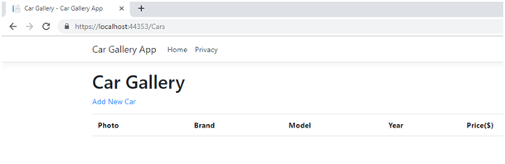

**Create Method and View**

Right-click on the ***Create***method in the *CarsController*and select ***Add View…***

Then, select the template and model class as shown below in the red box and click Add.

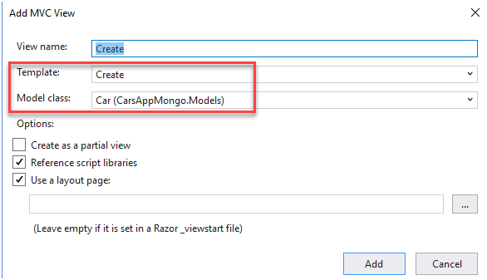

Go to the ***Create.cshtml*** and remove the form group related to *Id* field:

<div class="form-group"> <**label** **asp-for**="Id" class="control-label"></**label**> <**input** **asp-for**="Id" class="form-control" /> <**span** **asp-validation-for**="Id" class="text-danger"></**span**></div>

Change the ***Create POST method*** in the *CarsController.cs* with the following code:

Now, we can create our first record.

Run the application, click *Car Gallery App* and click ***Add New Car***.

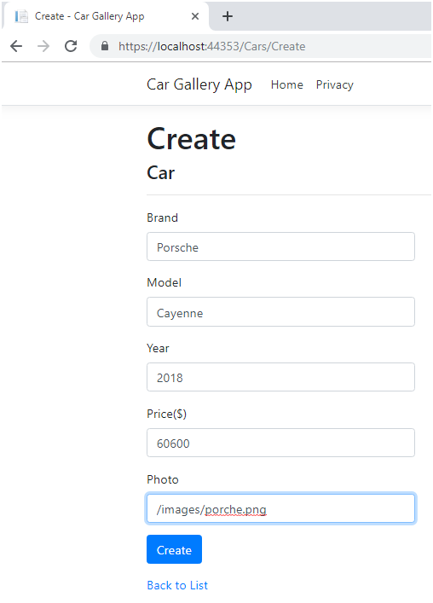

(*You need to create images folder in the****wwwroot****folder of the project and add the pictures there*)

After clicking *Create*, our first record is shown in the *Index*view as below:

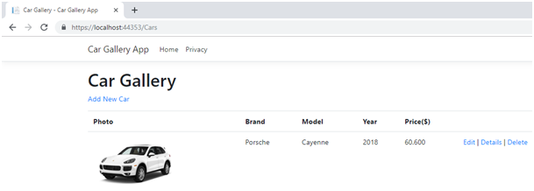

When we click *Create*button, *Create POST method* in *CarsController* runs.

We can check the record from the database by the following command:

db.Cars.find().pretty()

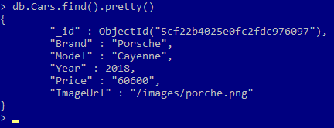

**Edit Method and View**

Right-click on the ***Edit***method in the *CarsController.cs* and select ***Add View…***

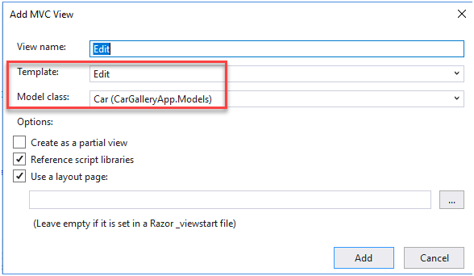

Go to ***Edit.cshtml*** and remove the form group related to *Id* field:

<div class=”form-group”> <**label** **asp-for**=”Id” class=”control-label”></**label**> <**input** **asp-for**=”Id” class=”form-control” /> <**span** **asp-validation-for**=”Id” class=”text-danger”></**span**></div>

In the *CarController.cs*, change ***Edit GET and POST methods*** as below:

*EDIT GET method* is invoked when we select *Edit*link in the *Index*view:

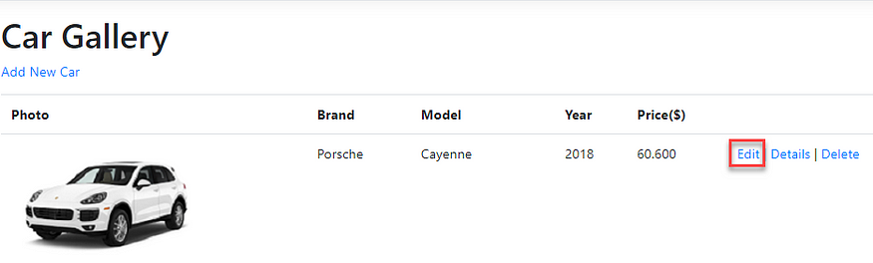

*EDIT POST method* is invoked when we click *Save*button in the following window:

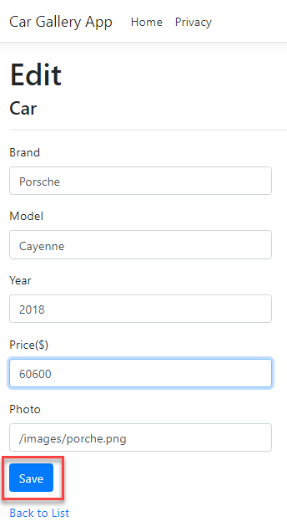

**Details Method and View**

Right-click on the ***Details***method in the *CarsController.cs* and select ***Add View…***

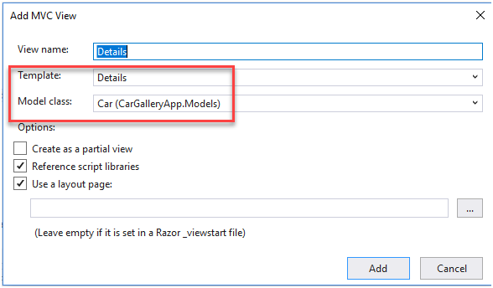

Change ***Details.cshtml*** with the following code (*similar changes that we did in other views*):

Change the ***Details method*** in the *CarController.cs* with the following code:

*This is the same code as the Edit GET method.*

When you run the application and click the *Details*link, you should see the output as below:

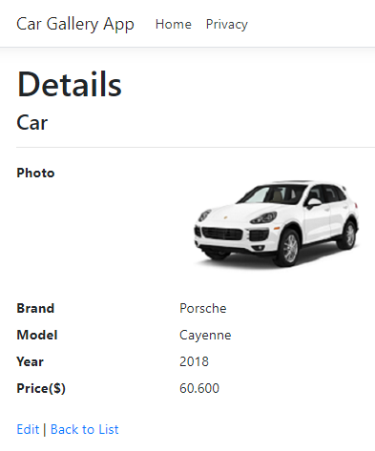

**Delete Method and View**

Right-click on the ***Delete***method in the *CarsController.cs* and select ***Add View…***

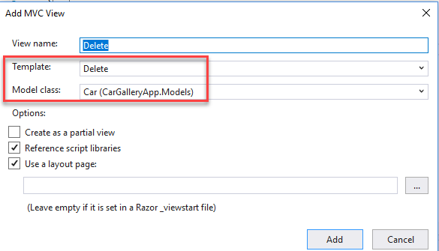

Change ***Delete.cshtml*** with the following code (*similar changes that we did in the other views*):

Change ***Delete GET and POST methods*** in the *CarController.cs* as below:

You should see the following output when you click *Delete*link:

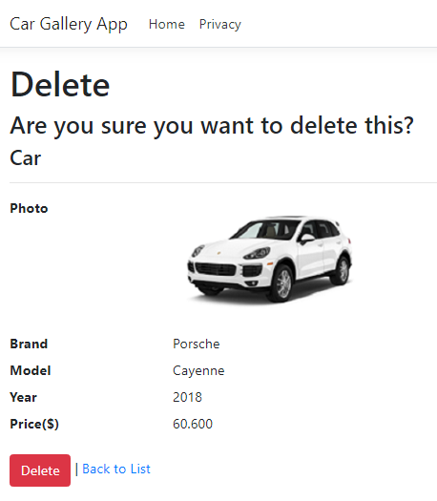

After deleting this record *Index*view will be empty and there will be no records in the *Cars*collection in the database:



Now that we have implemented all our methods and views for CRUD operations, we can insert other cars to our gallery and get a nice view like below :)



You can access the project from this [Github repository](https://github.com/kilicars/AspNetCoreWebAppMongoDB" \t "_blank).

I hope you found this post easy to follow and helpful. Please let me know if you have any questions and/or comments in the responses below.

If you are interested in .NET Core and want to find out more, you can check this [.NET Core publication](https://medium.com/net-core). The posts in the publication are as below:

* [Introduction to .NET Core](https://medium.com/net-core/introduction-to-net-core-adbf1962d57d)
* [ASP.NET Core MVC Web Application (Project Structure)](https://medium.com/net-core/asp-net-core-mvc-web-application-project-structure-3ccaa244fa66)
* [Build a Web App with ASP.NET Core MVC and EF Core](https://medium.com/net-core/building-a-web-application-using-asp-net-core-mvc-and-entity-framework-core-15ee6192b3f3)
* [How To Build a RESTful API with ASP.NET Core](https://medium.com/net-core/how-to-build-a-restful-api-with-asp-net-core-fb7dd8d3e5e3)

If you want, you can follow this publication and be informed when a new post arrives.

And if you liked this post, please clap your hands 👏👏👏

Bye until to the next post!

Keep coding :)

***References***

[*https://docs.microsoft.com/en-us/aspnet/core/tutorials/first-mongo-app?view=aspnetcore-2.2&tabs=visual-studio*](https://docs.microsoft.com/en-us/aspnet/core/tutorials/first-mongo-app?view=aspnetcore-2.2&tabs=visual-studio)